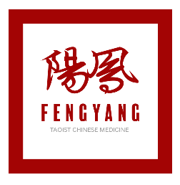
FengYang Taoist Chinese Medicine
Client Testimony/Photo Authorization and Release Form

I, _______________________________________, understand my testimonial or case study may be used in publication and promoting Dr. Ming Wu, his staff and practitioners of Fengyang TCM and WuHealing.
I authorize Dr. Ming Wu and his staff to use my name, photograph, brief biographical information and testimonial. I grant Dr. Ming Wu, its representatives and employees the right to use my name, photograph, brief biographical information, case study, videos & podcasts and the testimonial in various marketing initiatives. I understand that this information may be used in various mediums for such purposes as publicity, illustration, advertising, book publications, videos & podcasts, and web content.
I authorize Dr. Ming Wu to copyright, use and publish these materials in both print and electronic formats for purposes of publicizing his work.
In addition, I waive any right to inspect or approve the finished product wherein my likeness or my testimony appears. I agree that I will make no monetary or other claim against Dr. Ming Wu, his staff and practitioners for the use of my name, photograph, brief biographical information, case study and testimonial.

I have read, understand and agree to the above.

_______________________________________
Client Testimonial Provider Signature

_______________________________________
Printed Name

_______________________________________
Date

